**Create virtual machine scale set**

You can deploy a scale set with a Windows Server

1. Click **Create a resource** in the upper left-hand corner of the Azure portal.
2. Search for *scale set*, choose **Virtual machine scale set**, then select **Create**.
3. Enter a name for the scale set, such as *kpscaleset*.
4. Select your desired OS type, such as *Windows Server 2016 Datacenter*.
5. Enter your desired resource group name, such as *myResourceGroup*, and location, such as *East US*.
6. Enter your desired username and select which authentication type you prefer.

1. Select a load balancing option, such as *Load balancer*, under **Choose Load balancing options**. Enter the remaining details for your load balancing option. For example, for *Load balancer* you need to enter a **Public IP address name** and **Domain name label**.
2. Enter the virtual network details under **Configure Virtual Networks**. For example, you can create a new virtual network, *kpvn* and a new subnet, *default*.A screenshot of a cell phone

   Description automatically generated
3. To confirm the scale set options, select **Create**.

After creating Vmscaleset

## Connect to a VM in the scale set

When you create a scale set in the portal, a load balancer is created. Network Address Translation (NAT) rules are used to distribute traffic to the scale set instances for remote connectivity such as RDP or SSH.

To view these NAT rules and connection information for your scale set instances:

1. Select the resource group you created in the previous step, such as myResourceGroup.
2. From the list of resources, select your **Load balancer**,
3. Choose **Inbound NAT rules** from the menu on the left-hand side of the window.

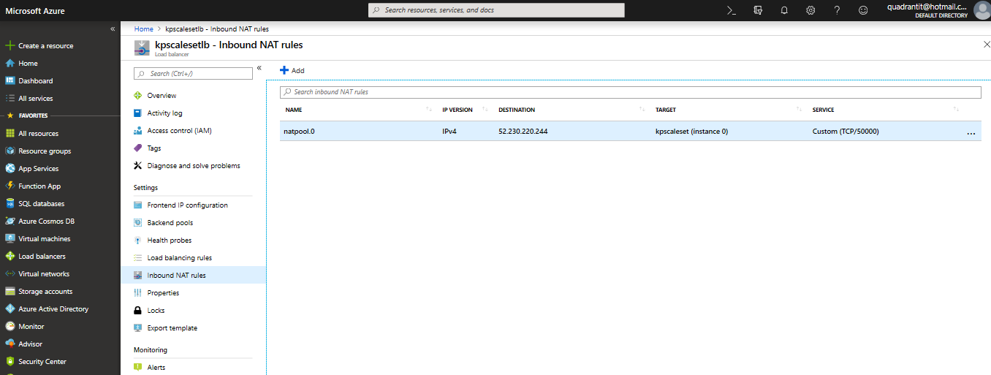

You can connect to each VM in the scale set using these NAT rules. Each VM instance lists a destination IP address and TCP port value. For example, if the destination IP address is 104.42.1.19 and the TCP port is 50001